**PIZZA SALES SQL QUERY**

**A.KPI’s:-**

**1.Total Revenue:-**

**\*\***select sum(total_price) AS Total_Revenue from pizza_sales

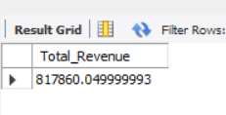

**2.Average Order Value**

**select sum(total_price)/count(distinct order_id) Avg_Order_value from pizza_sales

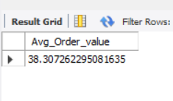

**3.Total Pizzas Sold**

**\*\*** **select sum(quantity) as Total_Pizza_Sold from pizza_sales**

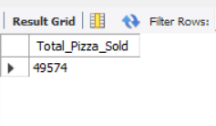

**4.Total Pizzas Order**

**select count(distinct order_id) as Total_Pizza_Order from pizza_sales

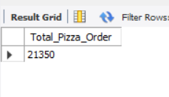

**4.Avg_Pizzas Per Order**

**select cast(cast(sum(quantity) as decimal(10,2)) /cast(count(distinct order_id) as decimal(10,2)) as decimal(10,2)) as Avg_Pizza_Perorder from pizza_sales

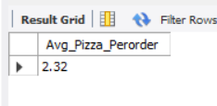

**B.Charts Requirement:-**

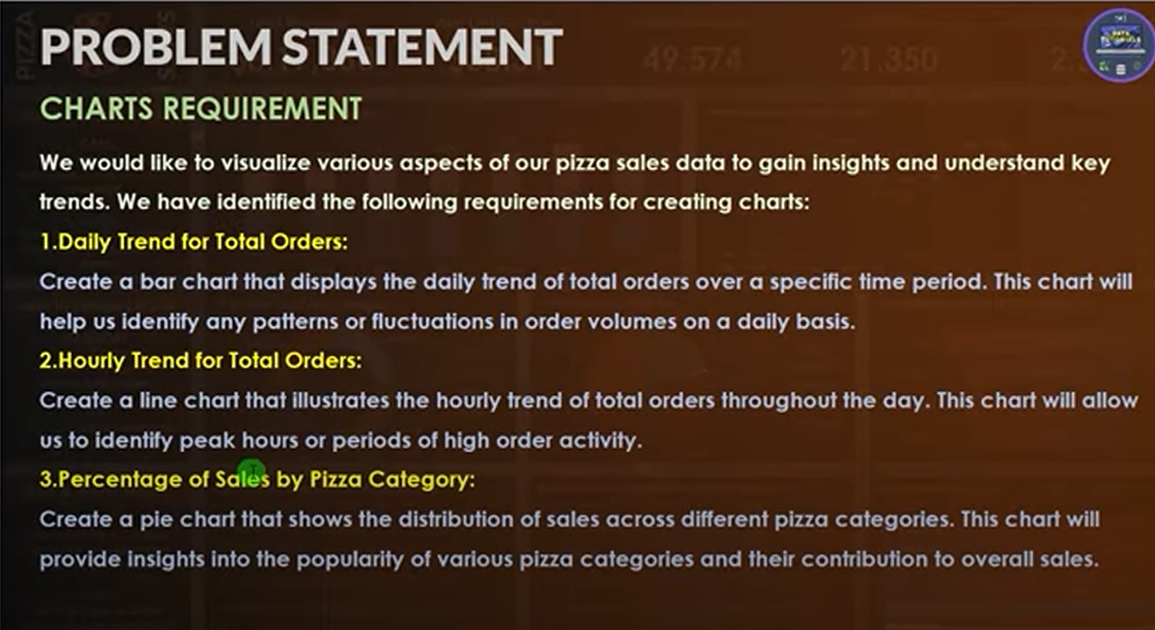

**1.Daily Trend for Total Orders:**

**\*\***select Dayname(str_to_date(order_date,'%d-%m-%Y')) as Order_Day ,

count(distinct order_id) as Total_Orders

from pizza_sales

group by Dayname(str_to_date(order_date,'%d-%m-%Y'));

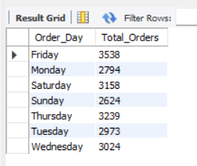

**2.Hourly Trend for TotalOrders:**

select monthname(str_to_date(order_date,'%d-%m-%Y')) as Month_Name, count(distinct order_id) as Total_orders

from pizza_sales

group by monthname(str_to_date(order_date,'%d-%m-%Y'))

order by Total_orders desc;

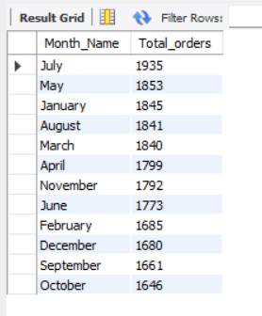

**3.Percentage of Sales by Pizza Category:**

* select pizza_category,sum(total_price)*100/ (select sum(total_price) from pizza_sales) as pct_Total_Sales
* from pizza_sales
* group by pizza_category;

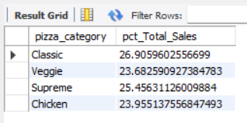

----**ORDERS OF HIGHEST CATEGORY OF PIZZA**------------------------------------------------------------------------

select pizza_category,sum(total_price) as Total_sales,sum(total_price)*100/ (select sum(total_price) from pizza_sales where monthname(str_to_date(order_date,'%d-%m-%Y')) = 'January') as pct_Total_Sales

from pizza_sales

group by pizza_category

select pizza_category,sum(total_price) as Total_sales,CAST(sum(total_price)*100/ (select sum(total_price) from pizza_sales where monthname(str_to_date(order_date,'%d-%m-%Y')) = 'January') AS DECIMAL(10,2))as pct_Total_Sales

from pizza_sales

group by pizza_category

ORDER BY pct_Total_Sales desc ;

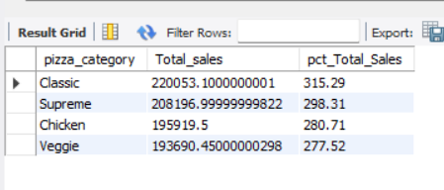

select pizza_size,cast(sum(total_price) as decimal(10,2)) as Total_sales,CAST(sum(total_price)*100/ (select sum(total_price) from pizza_sales where monthname(str_to_date(order_date,'%d-%m-%Y')) = 'January') AS DECIMAL(10,2))as pct_Total_Sales

from pizza_sales

group by pizza_size

order by pct_Total_Sales;

* ORDER BY pct_Total_Sales desc ;
* 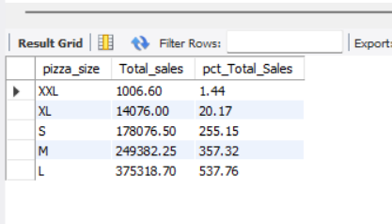
* 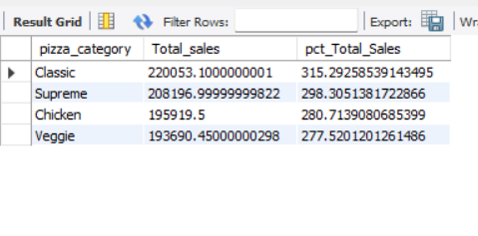

**----EXAMPLES----**Sales only in month of January

* select pizza_category,sum(total_price) as Total_sales,sum(total_price)*100/ (select sum(total_price) from pizza_sales) as pct_Total_Sales
* from pizza_sales
* where monthname(str_to_date(order_date,'%d-%m-%Y')) = 'January'
* group by pizza_category;

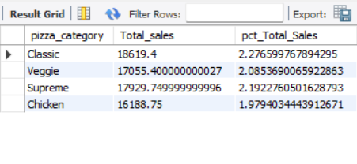

------Where clause should use with subquery

select pizza_category,sum(total_price) as Total_sales,sum(total_price)*100/ (select sum(total_price) from pizza_sales where monthname(str_to_date(order_date,'%d-%m-%Y')) = 'January') as pct_Total_Sales

from pizza_sales

* + **group by pizza_category;**

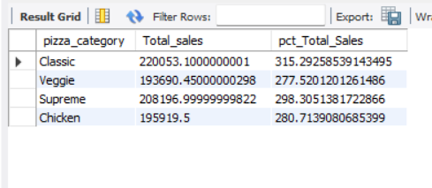

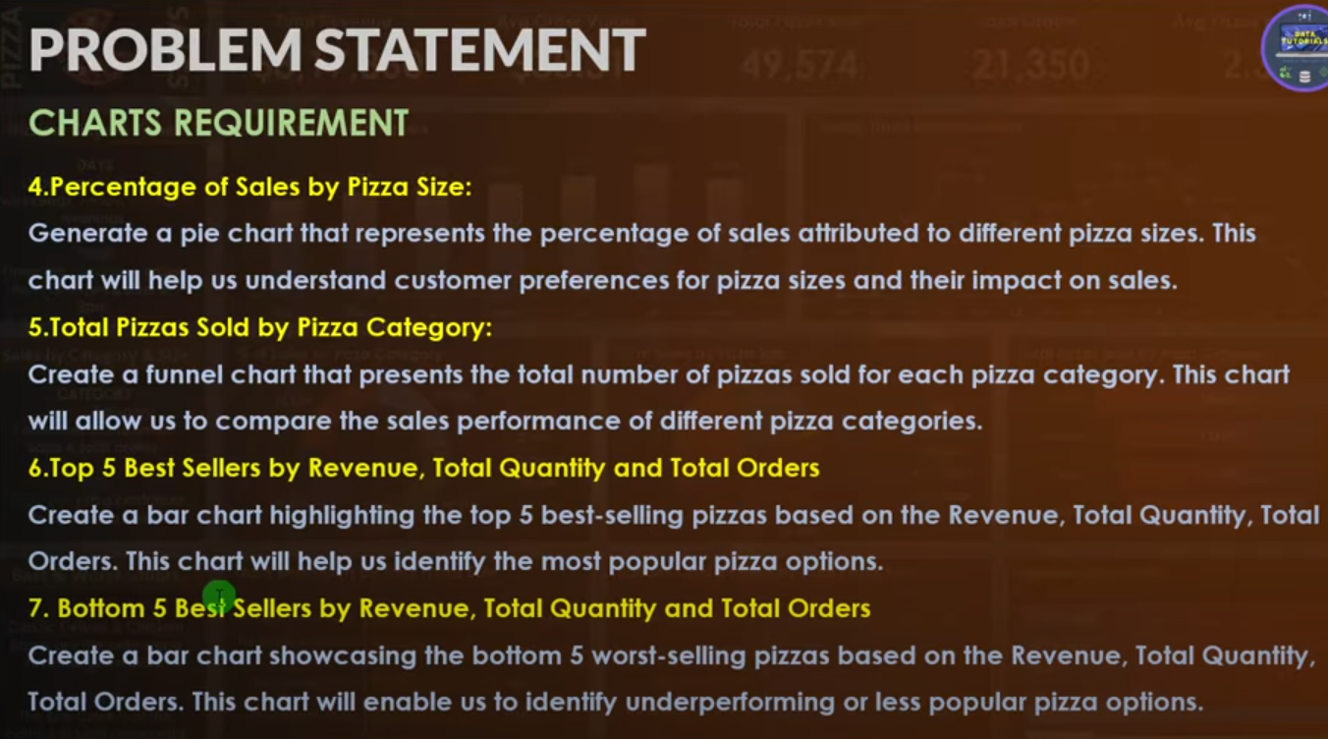

6.**Top 5 Best sellers by revenue(total_sales),total quantity and total orders**

**select pizza_name,sum(total_price) as Total_Revenue**

**from pizza_sales**

**group by pizza_name**

**order by Total_Revenue desc**

**limit 5;**

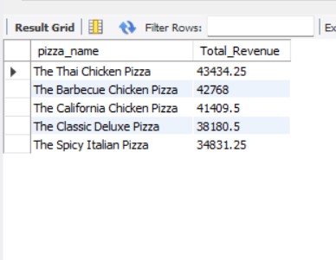

**Bottom 5 -------**

**select pizza_name,sum(total_price) as Total_Revenue,sum(quantity) as Total_quantity,count( distinct order_id) as Total_Orders**

**from pizza_sales**

**group by pizza_name**

**order by Total_Revenue ,Total_quantity,Total_Orders asc**

**limit 5;**

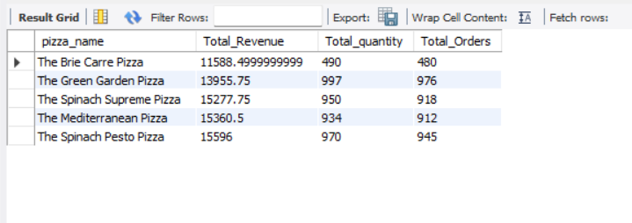

Powerbi query

B.EDA

1.Load data from mysql database

2.Data Cleaning

* Pizza size-L,M,XXL---gives full name
* **Home-transform data-power query**
* **Select-pizza_size-right click-replace values [L-Large,M-Medium,XL-X-Large…**
* **Close and apply**

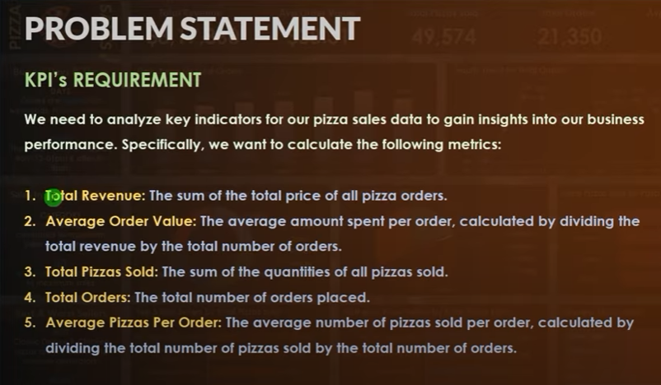

* USE DAX FUNCTION
* RIGHT CLICK ON ANY ATTRIBUTE-MEASURE
* **1.Total_Revenue = sum( 'pizza_shops pizza_sales'[total_price])**
* **4.Total_Orders = DISTINCTCOUNT( 'pizza_shops pizza_sales'[order_id])**
* **2.Avg Order Value = [Total_Revenue]/[Total_Orders]**
* **3.Total Pizzas Sold = sum('pizza_shops pizza_sales'[quantity])**
* **5.** **Avg Pizzas Per Order= [Total Pizzas Sold]/[Total_Orders]**
* Go to Visuals-New Card-Create KPI
* 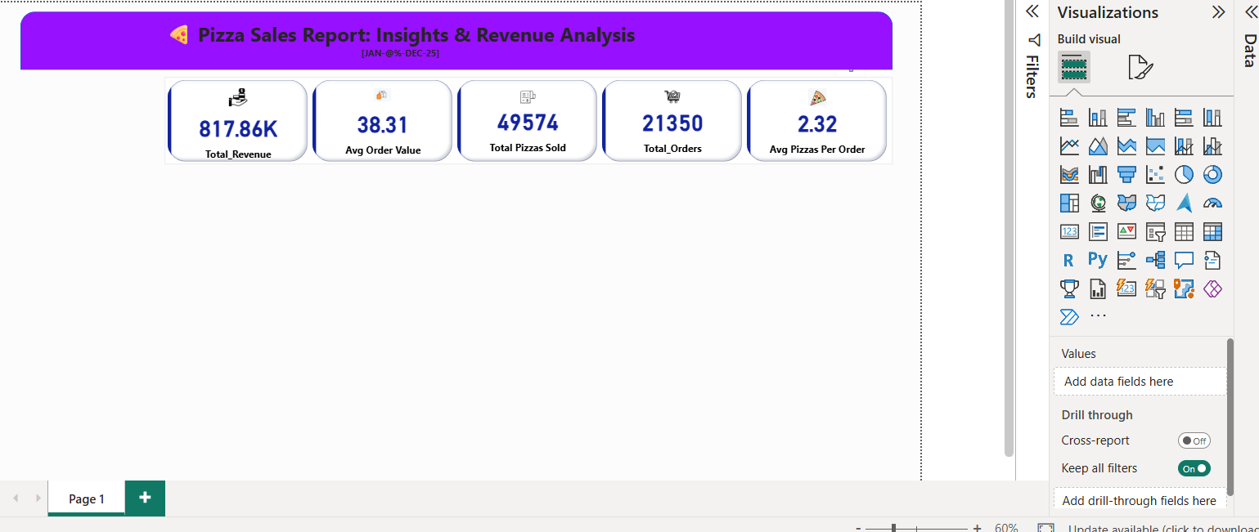
* Create Charts
* 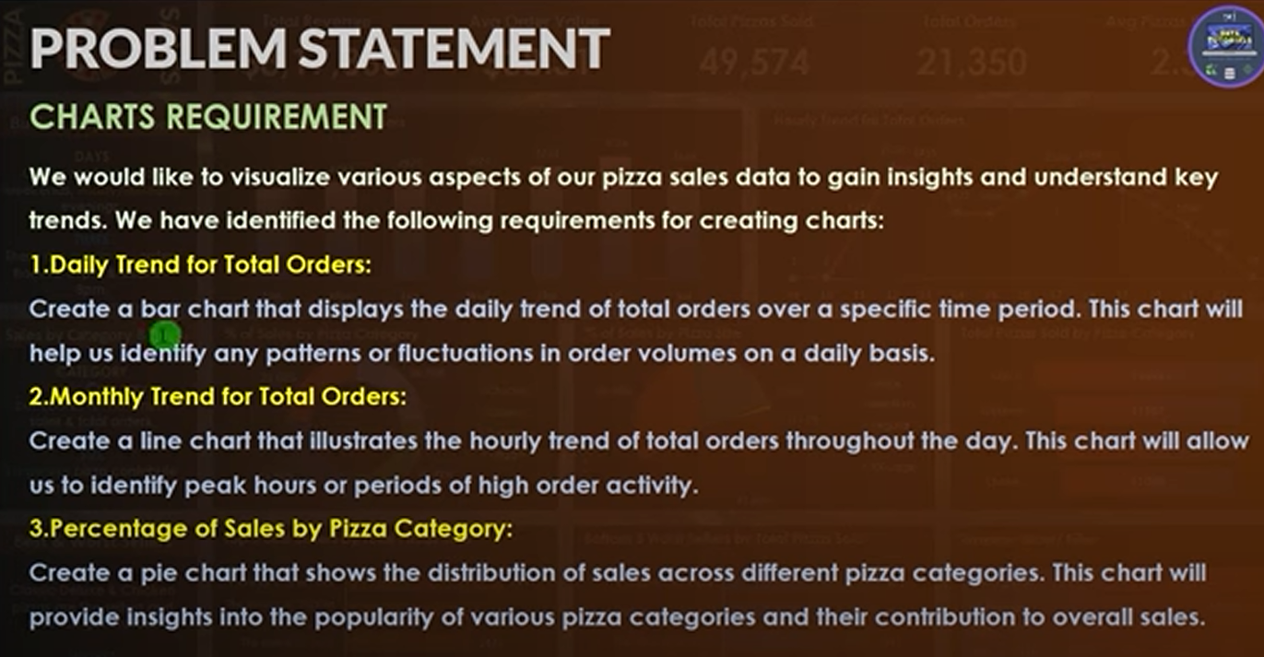
* 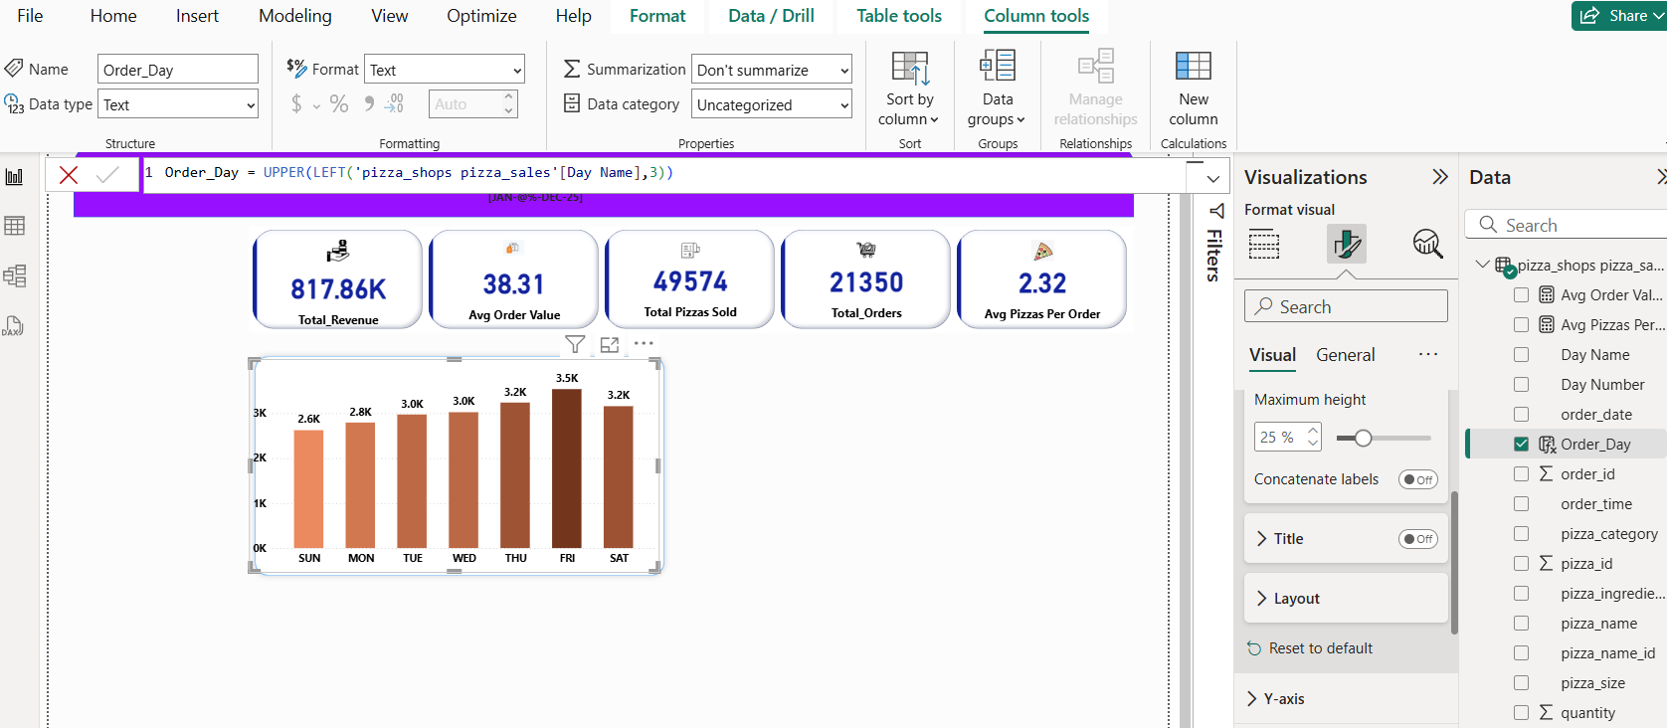
* 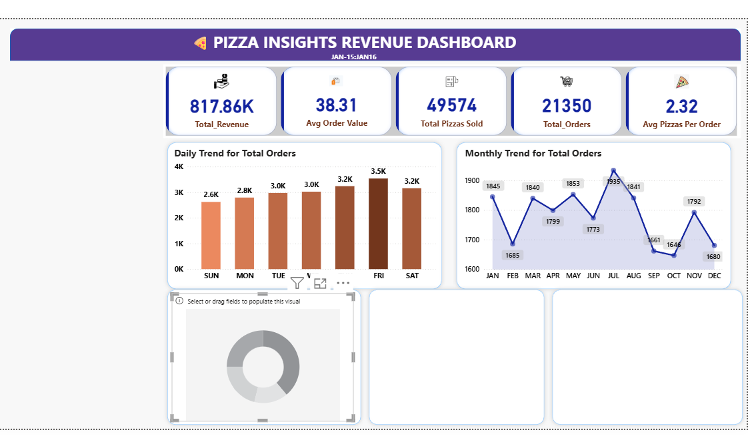
* Total Revenue by pizza category
* X-axis-Pizza category
* Y-axis-Total revenue
* Total Revenue by pizza Size
* X-axis-Pizza Size
* Y-axis-Total revenue
* ----rotation -2%
* 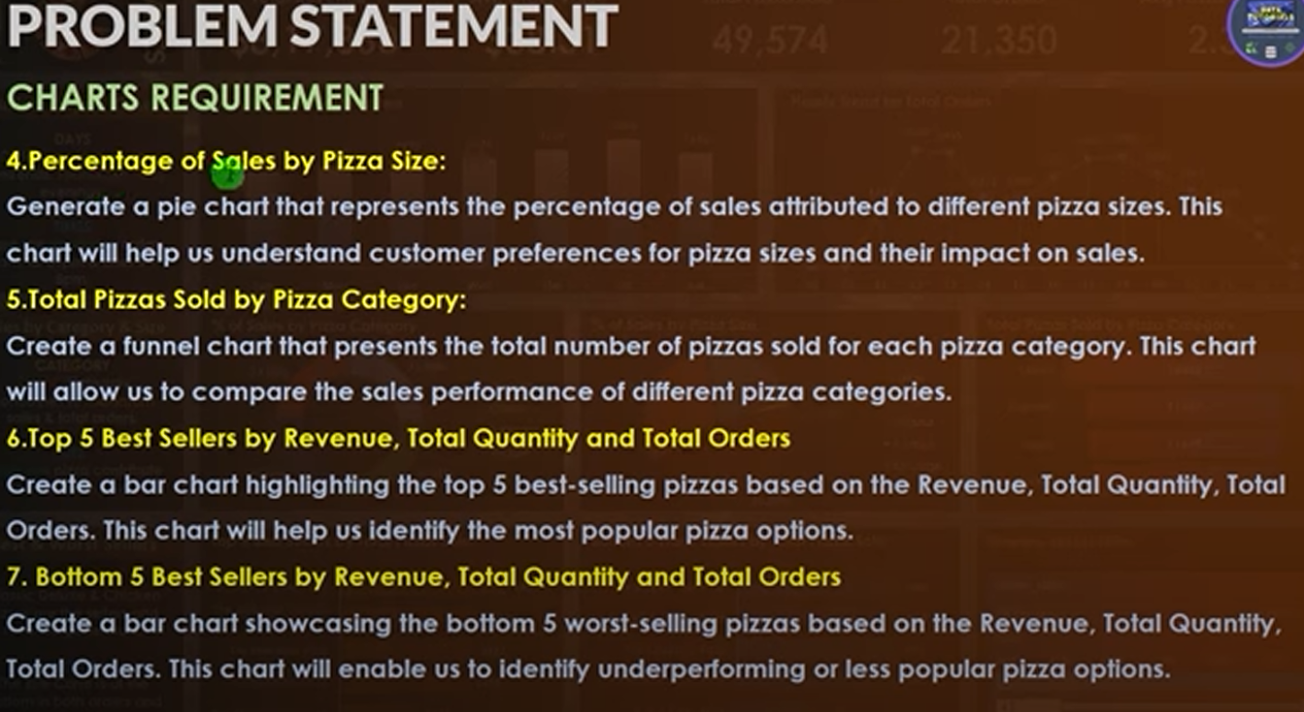
* % of sales by pizza sale
* X-axis-
* Y-axis-

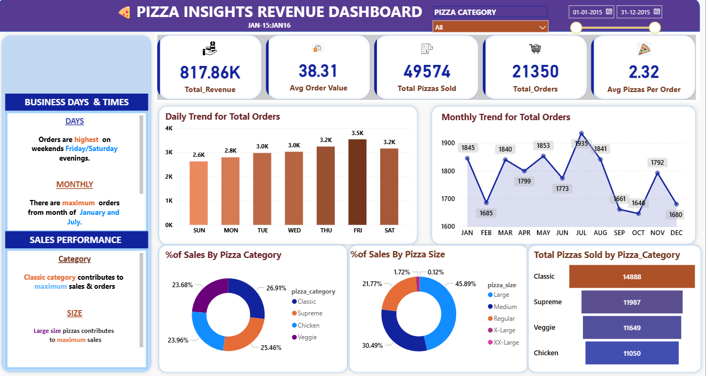

---------------------------------------------------------------------------NEXT PAGE-BEST/WORST SELLERS

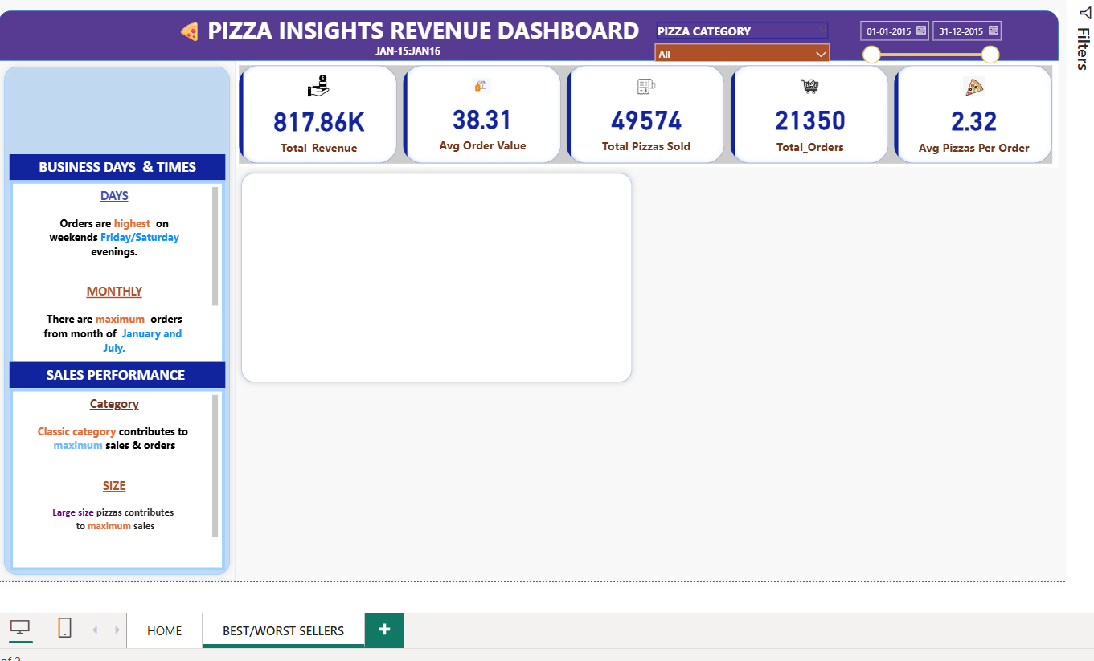

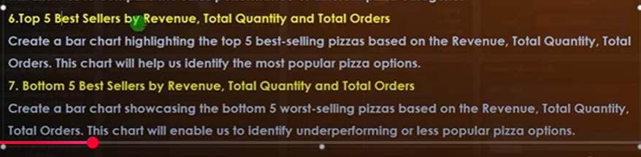

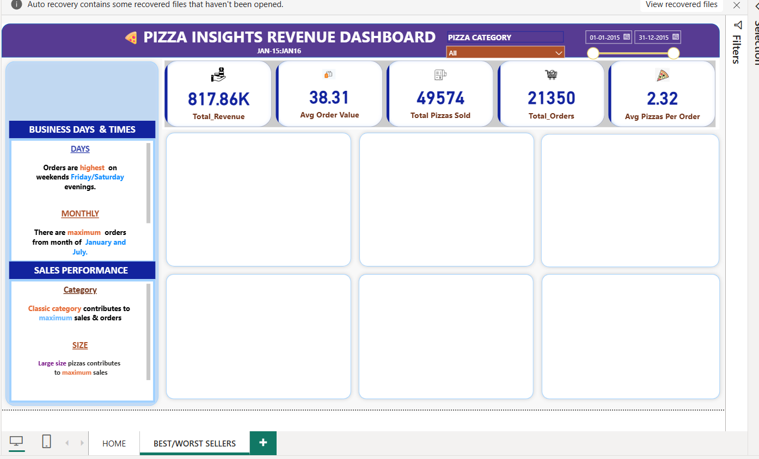

--TOTAL SELLERS BY REVENUE

---BAR CHART

X-AXIS=PIZZA NAME,Y-AXIS==TOTAL REVENUE

FILTER SECTION

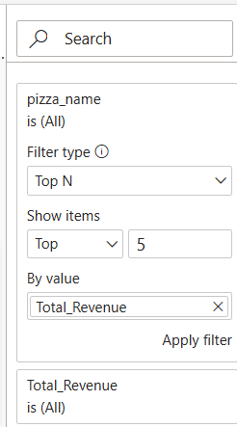 APPLY FILTER

